# The Efficiency Paradox

It is one of those curious things that often, in life, the course of action that seems best to our naïve common sense is, in fact, quite bad. Following what seems like ‘a good idea at the time’ leads to the opposite – a bad result.

The current wisdom is that same holds for economic logic writ large. The case in point is energy conservation and the concept of the [Khazzoom-Brookes Postulate](https://en.wikipedia.org/wiki/Khazzoom%E2%80%93Brookes_postulate). The narrative of the postulate, which is attributed to the ideas of the economists Daniel Khazzoom and Leonard Brookes from the 1980s, in goes something like this:

For decades, we’ve heard from the powers that be that the energy crisis can be averted simply by conserving energy. If only we were to use less electricity or drive more fuel-efficient cars or turn the thermostat down low, the world would be a better place. Since the US would use less fossil fuels, the population would be able to lower its dependence on foreign oil, reduce greenhouse gas emissions, and so on.

Unfortunately this public policy has exactly the opposite effect. As efficiency goes up by choices made at the microlevel, overall demand increases at the macrolevel and thus what seems like the right approach – use energy more efficiently – is in fact wrong.

The argument for the Khazzoom-Brookes postulate is often discussed within the context of the [Jevons Paradox](https://en.wikipedia.org/wiki/Jevons_paradox), which is basically an observation of seemingly non-intuitive behavior observed by William Stanley Jevons. Jevons observed that the overall demand for coal shot up dramatically after James Watt showed how to more efficiently use coal. Such a demand increase seems to go against the basic notion that a more efficient process should lower the consumption of a scarce resource and is due to the rebound effect.

A [rebound effect](https://en.wikipedia.org/wiki/Rebound_effect_(conservation)) is a measure of the difference between an efficiency improvement associated with a resource use and the corresponding change in its use. According to the Wikipedia article, the rebound effect (***RE***) is defined as: ***RE*** = (***E***-***D***)/***E***, where ***E*** is the percentage increase in efficiency and ***D*** is the percentage change in demand or use, with the convention that ***D*** is positive/negative for a decrease/increase in consumption (note that neither this notation nor the sign convention are discussed in that narrative). For example, a 4% increase in efficiency that corresponds to a 3% decrease in demand gives a ***RE*** = (4-3)/4 = 25%.

The Jevons Paradox occurs when the demand for the good is elastic; the slope of the efficiency-use curve (essentially a price-demand curve) is negative and less than 45 degrees. In this situation, the change in the relative price, due to the efficiency, is smaller (in some normalized sense) than the corresponding change in the use (relative demand). The paradox doesn’t result when the demand is inelastic (with a negative slope greater than 45 degrees) or when a decreasing price causes an even bigger drop in demand. The cases of elastic and inelastic demand are shown in the following figure (patterned after the ones in the Wikipedia article).

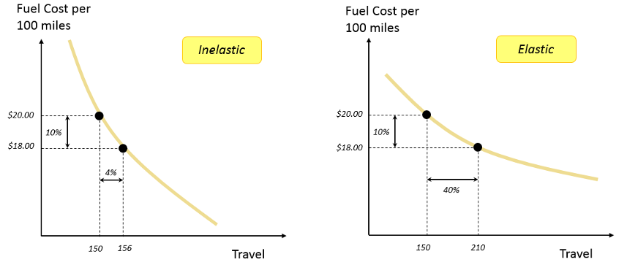

In both pictured cases, the fuel cost per 100 miles effectively drops by 10% due to improvement in efficiency. In an idealized, fantasy, world, where everyone only needed/wanted to travel 100 miles per week, the actual demand would drop as fuel efficiency lowered the number of gallons required. In a real-world situation, the lowered effective cost spurs additional activity.

If the new activity is inelastic, then the increase in demand offsets the savings and only 6% reduction of consumption is realized (10% in savings – 4% increase in usage). The rebound effect value is ***RE*** = (10%-6%)/10% = 40%. In the case where the activity spurred elastic, the lower effective cost spurs a great deal of additional activity and there is a 30% increase in consumption (10% of the 40% increase in travel is due to efficiency and the rest reflects the additional activity). The rebound effect value is RE = (10%+30%)/10% = 400% (the change in sign is due to the 30% being an increase in consumption rather than a decrease).

The spurred activity may result from two primary sources: 1) direct rebound and 2) indirect rebound. Direct rebound reflects the fact that consumers may choose to redirect additional spending at a now lower-priced commodity, perhaps taking that tour of the US that they always dreamed about but couldn’t afford. Indirect rebound reflects that as direct rebound effects takes place, the economy grows as does the demand for more resources.

This is all well and good from a theoretical side of the equation but specific observations of this behavior in a real economy are not so straightforward. Next column, I’ll examine the poster child of Khazzoom-Brookes and Jevons: US oil consumption.

I pulled 4 sets of data in order to try to see Jevons Paradox in action. These were: 1) Oil consumption by year (thousands of barrels), 2) Oil cost by year (raw cost per barrel), 3) US population by year, and 4) GDP by year (raw not inflation-adjusted). The sources are: [Item 1](https://www.eia.gov/totalenergy/data/browser/?tbl=T03.07C#/?f=A&start=1949&end=2016&charted=8-13), [Item 2](https://www.eia.gov/totalenergy/data/browser/?tbl=T03.07C#/?f=A&start=1949&end=2016&charted=8-13) (both from [www.eia.gov](http://www.eia.gov)), [Item 3](http://www.multpl.com/united-states-population/table), and [Item 4](http://www.multpl.com/us-gdp/table/by-year) (both from [www.multpl.com](http://www.multpl.com)).

The first graph of the data I tried was the per capita use of oil